Mengzhe fei

11200913

Mef382

CMPT 270: Assignment 2 External Documentation

1. Using compiler to compile all the code. Executing the final class called HospitalSystem by calling the main function inside the HospitalSystem. It invokes all the class inside the whole assignment.

The system has two style of working , console and dialog, the console working log is attached at last part of this assignment, and there are some screenshots of the dialog as well

2. Status of the Assignment The assignment is complete and runs without error. Every Method has been tested a minimum of 2 times. Additional tests could be added to make the validation more thorough.

3. UML Class Diagram

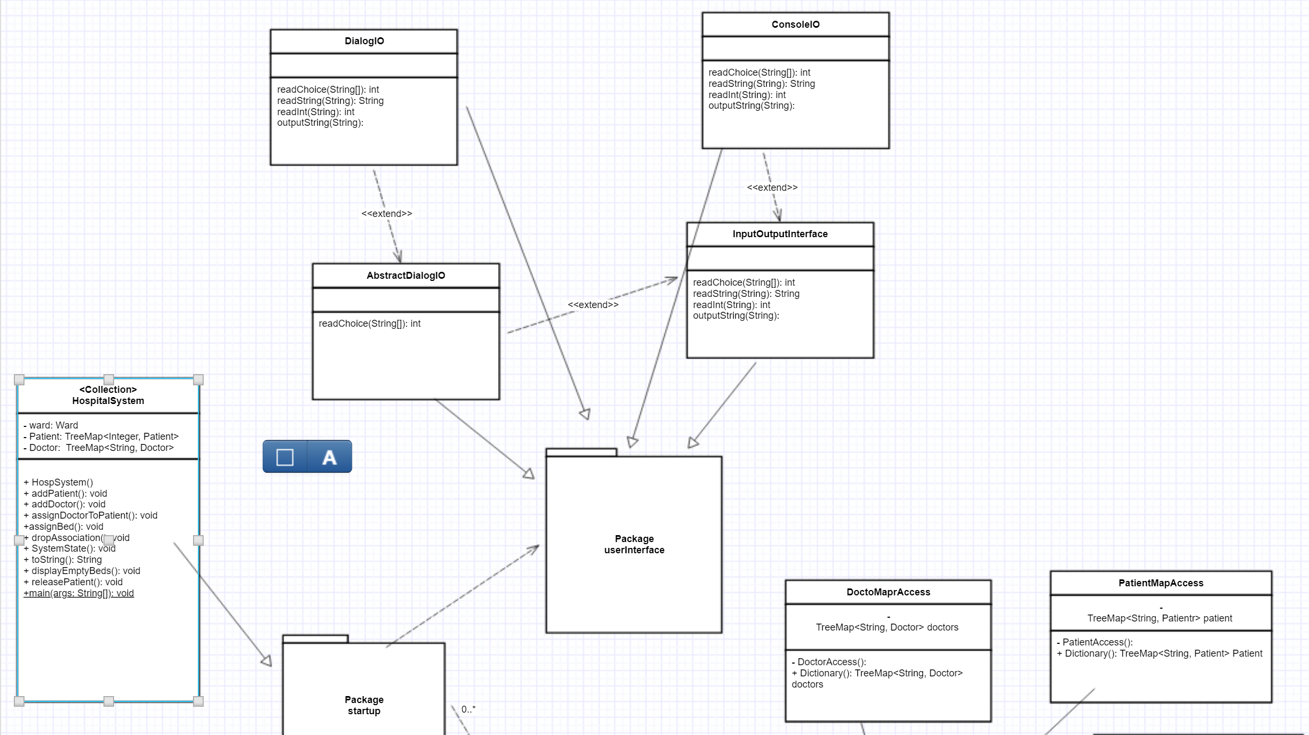

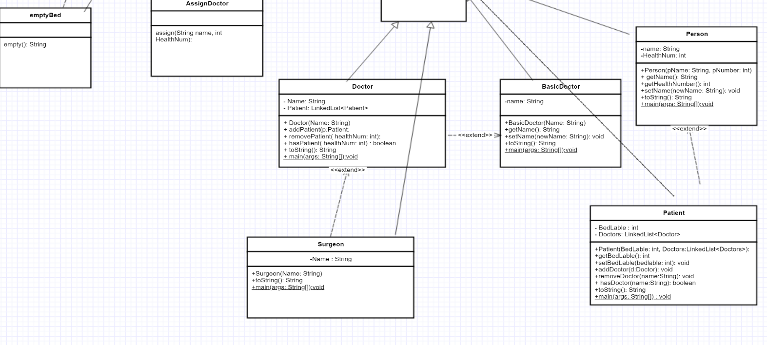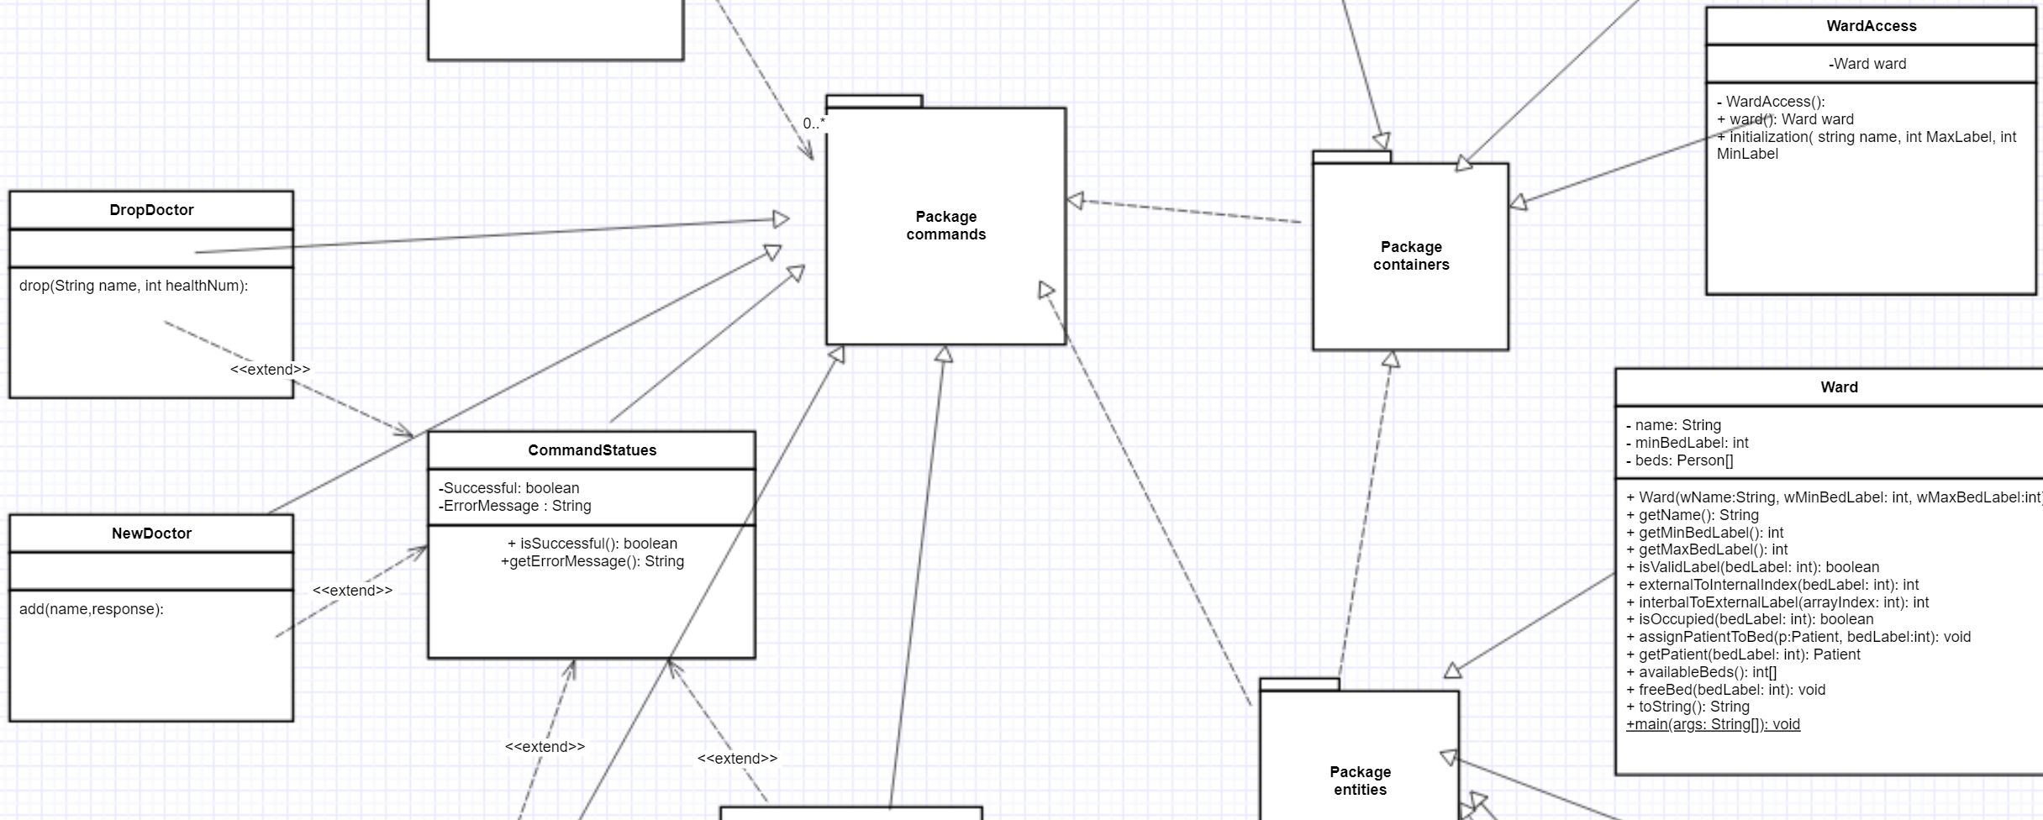

LOG:

Initializing the system...

Getting Ward information...

Enter the name of the Ward: ICU

Enter the integer label of the first bed: 10

Enter the integer label of the last bed: 20

Please select an operation to do

1: quit

2: add a new patient

3: add a new doctor

4: assign a doctor to a patient

5: display the empty beds of the ward

6: assign a patient a bed

7: release a patient

8: drop doctor-patient association

9: display current system state2

Getting Patient information...

Enter the name of the patient: feiwu

Enter the health number of the patient: 123

Please select an operation to do

1: quit

2: add a new patient

3: add a new doctor

4: assign a doctor to a patient

5: display the empty beds of the ward

6: assign a patient a bed

7: release a patient

8: drop doctor-patient association

9: display current system state3

Getting Doctor information...

Enter the name of the doctor: shabi

Is the doctor a surgeon? (yes or no)yes

1

in else

Please select an operation to do

1: quit

2: add a new patient

3: add a new doctor

4: assign a doctor to a patient

5: display the empty beds of the ward

6: assign a patient a bed

7: release a patient

8: drop doctor-patient association

9: display current system state4

Assigning a new Doctor-Patient Association...

Getting Patient information...

Enter the health number of the patient: 123

Getting Doctor information...

Enter the name of the doctor: shabi

Please select an operation to do

1: quit

2: add a new patient

3: add a new doctor

4: assign a doctor to a patient

5: display the empty beds of the ward

6: assign a patient a bed

7: release a patient

8: drop doctor-patient association

9: display current system state5

Empty Beds are

Bed 10is empty

Bed 11is empty

Bed 12is empty

Bed 13is empty

Bed 14is empty

Bed 15is empty

Bed 16is empty

Bed 17is empty

Bed 18is empty

Bed 19is empty

Bed 20is empty

Please select an operation to do

1: quit

2: add a new patient

3: add a new doctor

4: assign a doctor to a patient

5: display the empty beds of the ward

6: assign a patient a bed

7: release a patient

8: drop doctor-patient association

9: display current system state6

Assigning a Patient to a Bed...

Getting Patient information...

Enter the health number of the patient: 123

Enter the bed number for the patient: 11

Please select an operation to do

1: quit

2: add a new patient

3: add a new doctor

4: assign a doctor to a patient

5: display the empty beds of the ward

6: assign a patient a bed

7: release a patient

8: drop doctor-patient association

9: display current system state5

Empty Beds are

Bed 10is empty

Bed 12is empty

Bed 13is empty

Bed 14is empty

Bed 15is empty

Bed 16is empty

Bed 17is empty

Bed 18is empty

Bed 19is empty

Bed 20is empty

Please select an operation to do

1: quit

2: add a new patient

3: add a new doctor

4: assign a doctor to a patient

5: display the empty beds of the ward

6: assign a patient a bed

7: release a patient

8: drop doctor-patient association

9: display current system state7

Getting Patient information...

Enter the health number of the patient: 123

Please select an operation to do

1: quit

2: add a new patient

3: add a new doctor

4: assign a doctor to a patient

5: display the empty beds of the ward

6: assign a patient a bed

7: release a patient

8: drop doctor-patient association

9: display current system state5

Empty Beds are

Bed 10is empty

Bed 11is empty

Bed 12is empty

Bed 13is empty

Bed 14is empty

Bed 15is empty

Bed 16is empty

Bed 17is empty

Bed 18is empty

Bed 19is empty

Bed 20is empty

Please select an operation to do

1: quit

2: add a new patient

3: add a new doctor

4: assign a doctor to a patient

5: display the empty beds of the ward

6: assign a patient a bed

7: release a patient

8: drop doctor-patient association

9: display current system state9

The patients in the system are

Name: feiwu

Health number: 123

with doctors shabi,

The doctors in the system are

entities.Surgeon

Name: shabi

Patients: 123,

The ward is

Ward ICU with capacity 11 has the following patients:

bed 10:

bed 11:

bed 12:

bed 13:

bed 14:

bed 15:

bed 16:

bed 17:

bed 18:

bed 19:

bed 20:

Please select an operation to do

1: quit

2: add a new patient

3: add a new doctor

4: assign a doctor to a patient

5: display the empty beds of the ward

6: assign a patient a bed

7: release a patient

8: drop doctor-patient association

9: display current system state1

The patients in the system are

Name: feiwu

Health number: 123

with doctors shabi,

The doctors in the system are

entities.Surgeon

Name: shabi

Patients: 123,

The ward is

Ward ICU with capacity 11 has the following patients:

bed 10:

bed 11:

bed 12:

bed 13:

bed 14:

bed 15:

bed 16:

bed 17:

bed 18:

bed 19:

bed 20:

